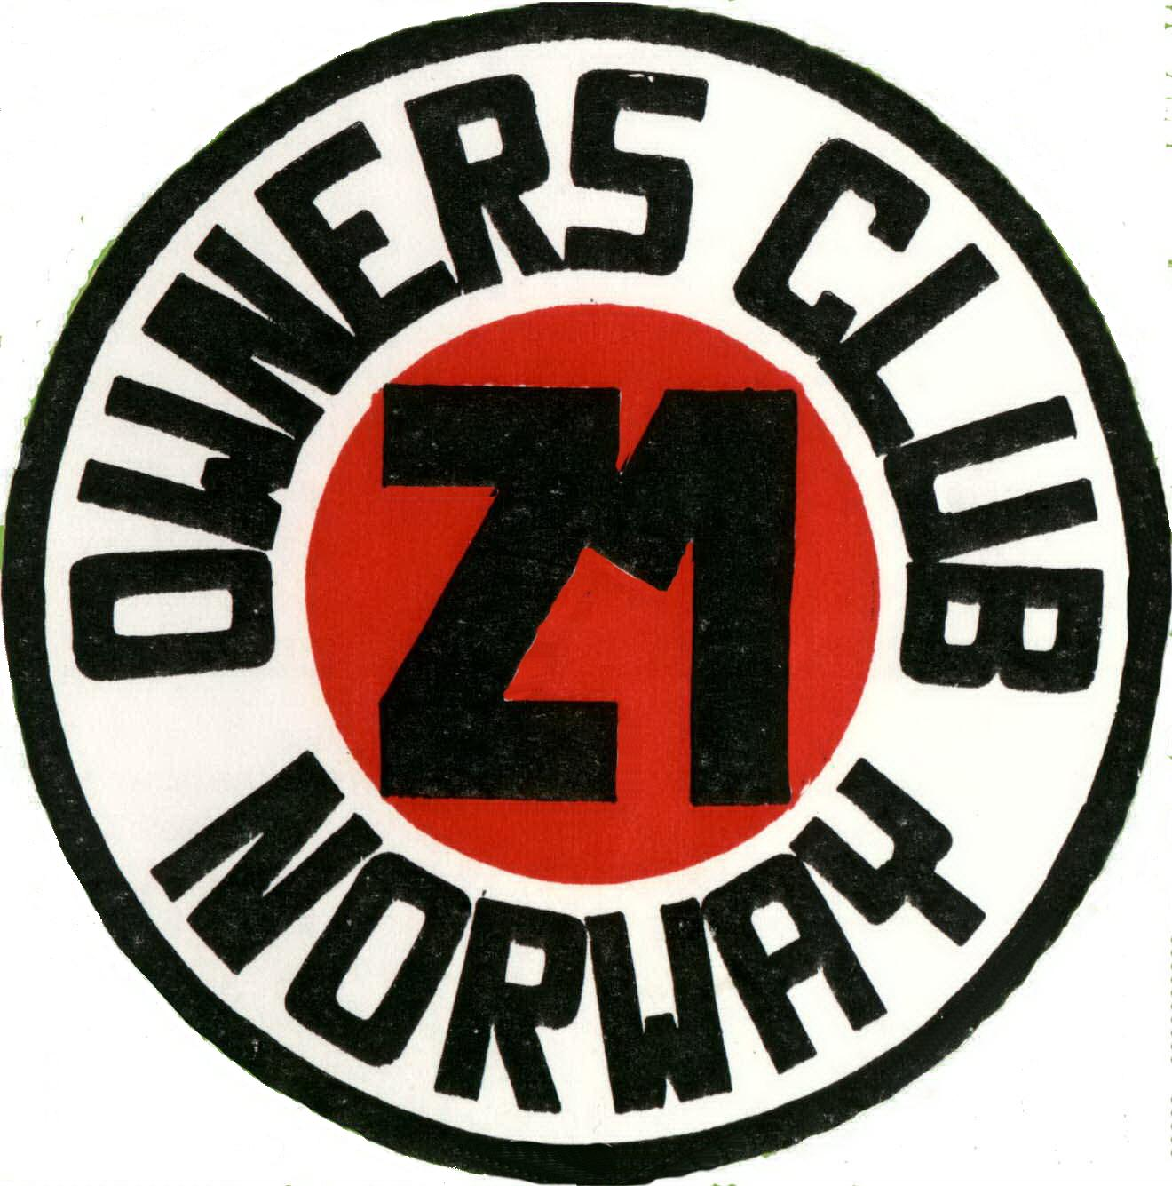 Z1OCN
Invite you to our 20. International rally
The rally will be arranged at Blaker, about 50 km north east of Oslo.
Weekend of 1. – 3. July 2011
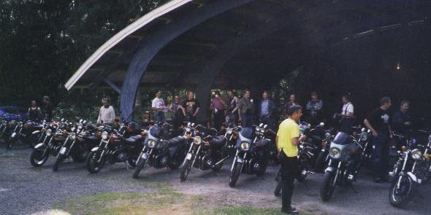
GPS: North: 59.98414, East: 11.34753
We invite all friends to our 20. Anniversary in Norway by the Z1 Owners Club Norway.
We hope to see many of our foreign friends from Germany, England, Denmark, Sweden, Finland and others. It would be great to meet you all at our anniversary in 2011.
If you got friends, who want to join you on the trip, bring them with or without a Z1.Your friend is ours.
We’re planning the rally to be the greatest in the Norwegian club ever, and need visitors to make it happen. Please contact the club for further information, we’ll try to answer all your questions.
If there’s any, of different reasons, who want to visit the rally without bikes, we might help you with transport from airport or ferries in Oslo. Of course, we want as many bikes as possible, but.........
If any of you want to be a contact for your country and make plans for the journey to our rally, please let us know and help us to make a good time in Norway.

If questions or ideas, contact us by mail: support@kawaz1.com
Website:
For Scandinavian friendes: www.kawaz1.com
In English: www.kawaz1.com/index_en.php

Best regards from Norway,
Z1OCN

